

AsiaPay PayGate

Integration Guide (For LiteCommerce 2.2 using Client Post Through Browser)
Table of Contents:
Part 1: Installation and setup of the module on LiteCommerce 2.2 (pages 3-5)
Part 2: Setup of Datafeed URL on AsiaPay (pages 6-9)

Part 1: Installation and setup of the module on LiteCommerce 2.2:

1. Login to your LiteCommerce Administrator Zone. E.g. (http://www.yoursite.com/admin.php)
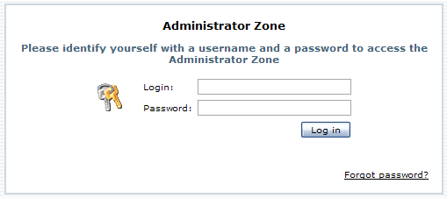

2. After login, go to left sidebar on Settings > Modules.
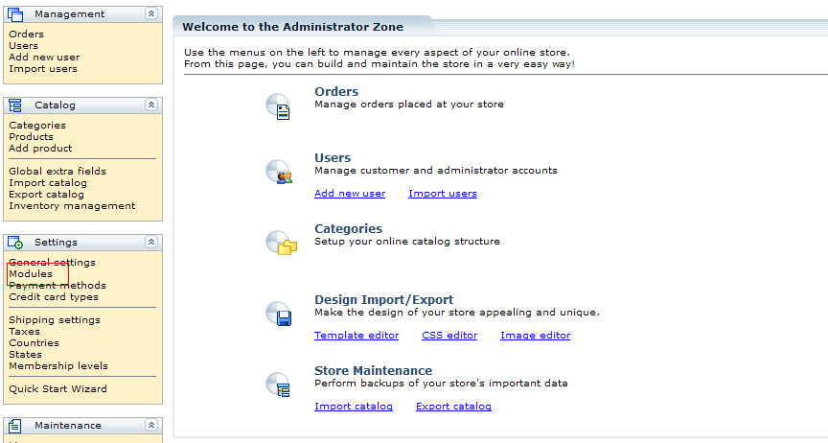

3. Browse for the Module (AsiaPayClientPost_add-on-2.0.tar) and click install.
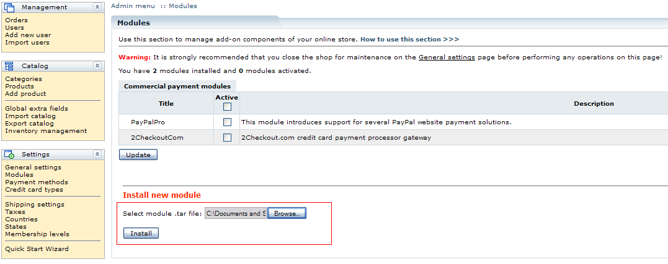

4. After Installation, click the “Payment method setup page” link.
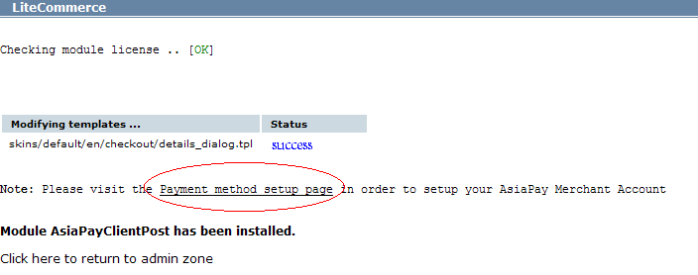

5. Setup the necessary information and click the “Update” button.
- Payment Gateway URL
- Merchant Id
- PayType
- PayMethod
- Currency
- Language
- Secure Hash Secret (optional)
- Prefix for Order Reference (optional)
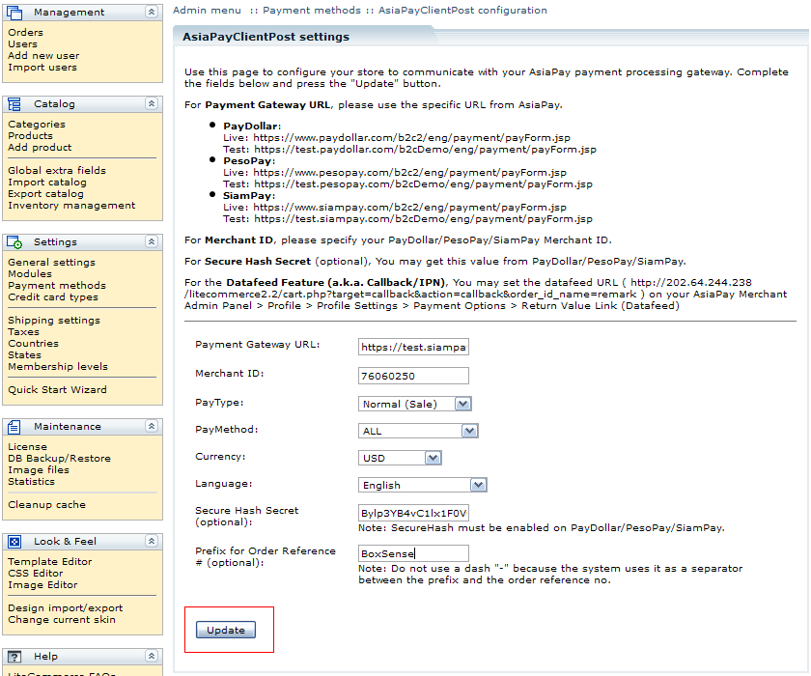

Part 2: Setup of Datafeed URL on AsiaPay

1. Login to your AsiaPay Account.
- PayDollar
  - Live: https://www.paydollar.com/b2c2/eng/merchant/index.jsp
  - Test: https://test.paydollar.com/b2cDemo/eng/merchant/index.jsp
- PesoPay
  - Live: https://www.pesopay.com/b2c2/eng/merchant/index.jsp
  - Test: https://test.pesopay.com/b2cDemo/eng/merchant/index.jsp
- SiamPay
  - Live: https://www.siampay.com/b2c2/eng/merchant/index.jsp
  - Test: https://test.siampay.com/b2cDemo/eng/merchant/index.jsp
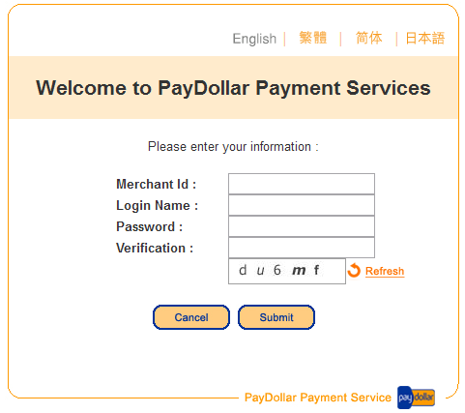

2. After login, Go to left sidebar on Profile > Profile Settings > Payment Options.
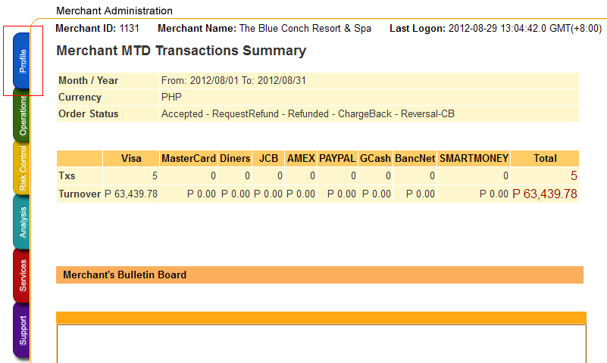

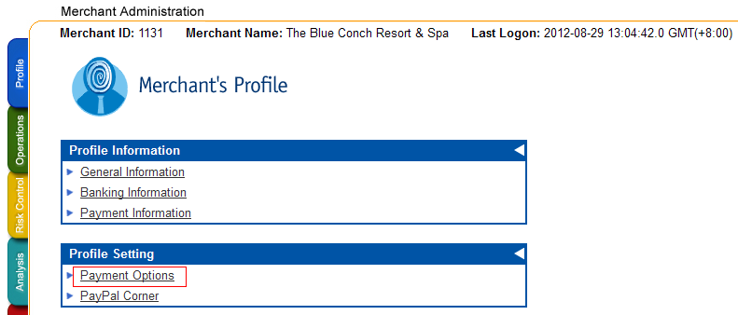

3. Click the “Enable” radio and set the datafeed URL on “Return Value Link” and click the “Update” button.
Datafeed URL E.g. http://www.yoursite.com/cart.php?target=callback&action=callback&order_id_name=remark
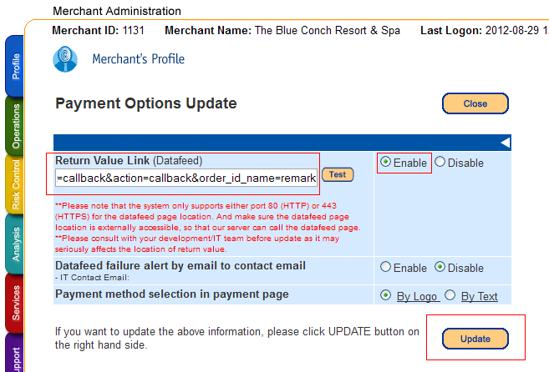

4. On the confirmation page, review your changes then click the “Confirm button”.
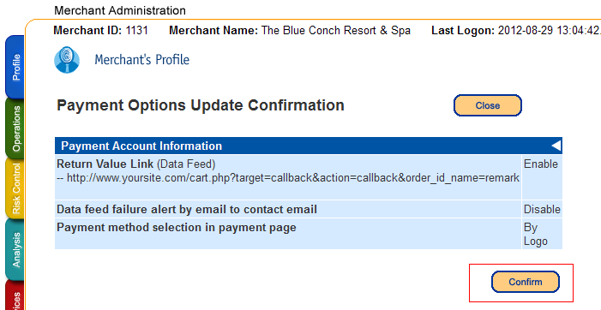
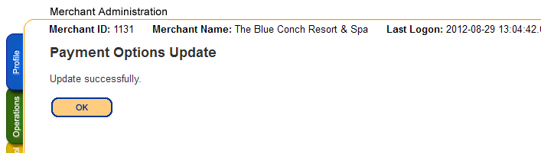

-- END --

